Lab 1

Ans 8.1)

|  |  |  |  |  |
| --- | --- | --- | --- | --- |
| Sensor4 | Sensor 3 | Sensor 2 | Sensor 1 | Output |
| 0 | 0 | 0 | 0 | 0 |
| 0 | 0 | 0 | 1 | 1 |
| 0 | 0 | 1 | 0 | 0 |
| 0 | 0 | 1 | 1 | 1 |
| 0 | 1 | 0 | 0 | 0 |
| 0 | 1 | 0 | 1 | 1 |
| 0 | 1 | 1 | 0 | 1 |
| 0 | 1 | 1 | 1 | 1 |
| 1 | 0 | 0 | 0 | 0 |
| 1 | 0 | 0 | 1 | 1 |
| 1 | 0 | 1 | 0 | 1 |
| 1 | 0 | 1 | 1 | 1 |
| 1 | 1 | 0 | 0 | 0 |
| 1 | 1 | 0 | 1 | 1 |
| 1 | 1 | 1 | 0 | 1 |
| 1 | 1 | 1 | 1 | 1 |

\**Note sensor 4,3 are redundant sensors. Sensor 2 is low priority and sensor 1 is high priority.*

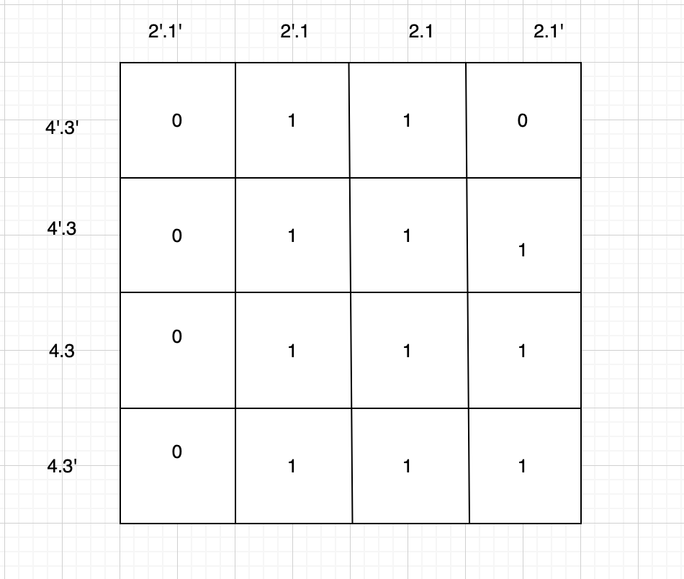

Sum of Products = 1 + 2 . 3 + 2 . 4

Synchroniser

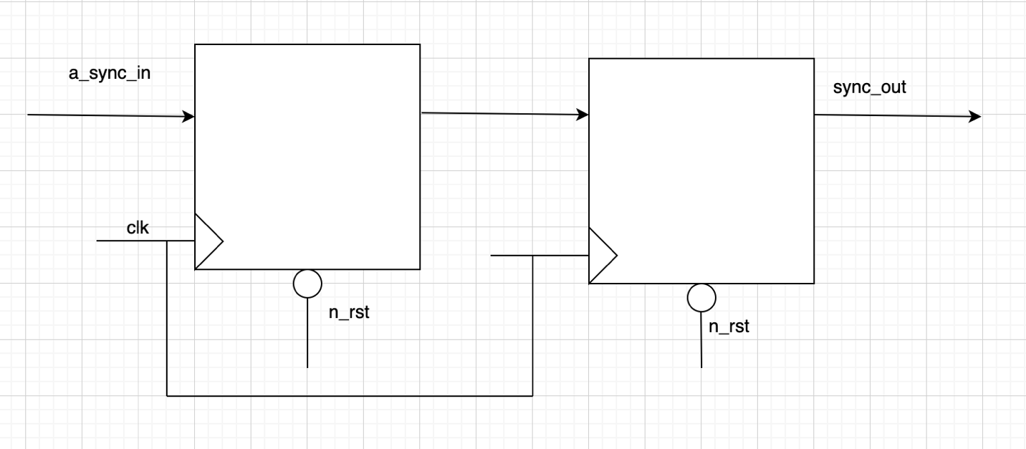

Series to Parallel

Parallel to series

